FINAL TEST
PART 1: (2ps)
Directions: In this part of the test, you will write ONE sentence that is based on a picture. With each picture, you will be given TWO words or phrases that you must use in your sentence. You can change the forms of the words and you can use the words in any order. Your sentences will be scored on
-Appropriate use of grammar and
-The relevance of the sentence to the picture

1.

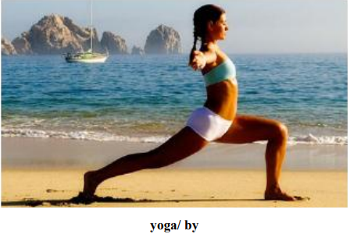

2.
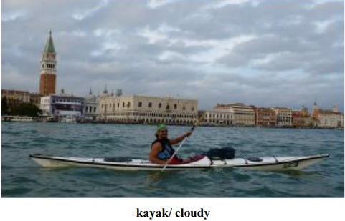

3.
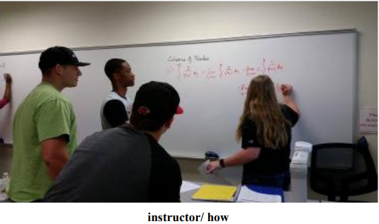

4.

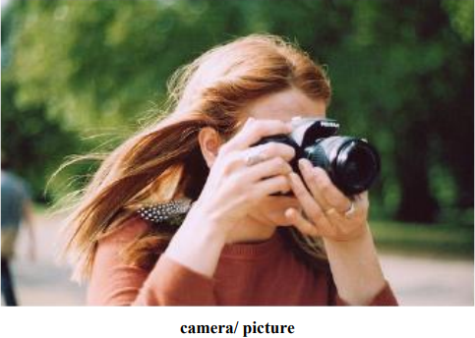

5.
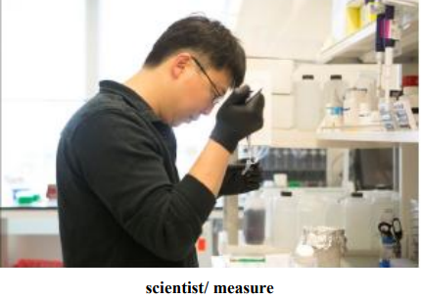

PERT 2: (3PS)
Directions: In this part of the test, you will show how well you can write a response to an email. Your response will be scored on
-The quality and variety of your sentences,
-Vocabulary, and
-Organization
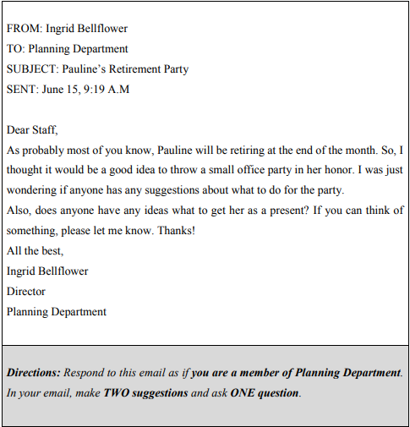

PART 3: (5ps)
Directions: in this part of the test, you will write an essay in response to a question that ask you to state, explain, and support your opinion on an issue. Typically an effective essay will contain 300 – 350 words. Your response will be scored on:
-Whether your opinion is supported with response and/ or examples,
-Grammar,
-Vocabulary, and
-Organization


